WELCOME TO THE JHB ZOO

The history of the Johannesburg Zoo
In 1904, the land that the Johannesburg Zoo covers was donated by the firm of the late Hermann Eckstein to the people of the City of Johannesburg to be used for recreation. Hermann Eckstein was involved in the development of the new mining town of Johannesburg. He had three million trees planted in an area which he named Sachsenwald, now the suburb of Saxonwold.
Since then, the Johannesburg Zoo has developed and evolved over the years. Many facilities were built, for example the animal hospital in 1936.
Public perception of the zoo changed in the 1960s when visitors wanted to see animals in larger, more natural enclosures. This was the start of the zoo's long-term plans to grow and improve the facility for both the animals and the visitors. These changes saw the upgrading of old and the creation new enclosures, the development of education and environmental programmes, and the zoo becoming part of local and international breeding programmes.

Overview
The Johannesburg Zoo is one of the most popular local tourist attractions situated in the leafy northern suburbs of Johannesburg. The zoo is open to the public 365 days a year, including the Christmas and Easter holidays. It offers visitors various fun night and day tours, school holiday programmes, clubs, venue hire and regular events for the public.
The zoo covers 55 hectares of land and houses over 320 species of animals, totalling approximately 2 000 animals.
With international accreditation, the zoo maintains a high standard of animal welfare, nutrition and ethical conduct to ensure the physical and psychological well-being of all its animals.

Did you know?
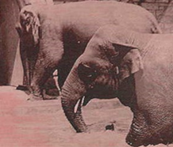
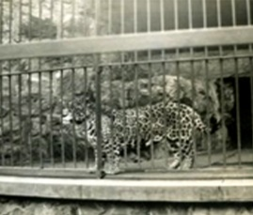
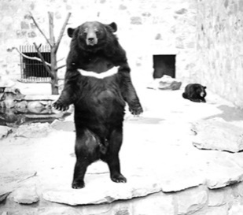
Figure 1: First Elephant
Figure 2: First Leopard
Figure 3: First Bear
The original animal collection consisted of one lion, one leopard, one giraffe, two Sable antelope bulls, one baboon, one pair of Rhesus monkeys, one pair of porcupines and one Golden eagle.

Here are some more fun facts:
- The first 'official' enclosure was built by the Town Council to house two young lions. Only the lions and leopard were in the public area at this stage.
- In 1910 the bandstand was built to host the popular brass band music of the day.
- Between 1913 and 1915 the stone elephant and rhino house were built. Also, at this time, one Asian elephant and one Bactrian camel were purchased and trained for rides.
- In 1961, for the first time, visitors older than16 were charged a fee to enter the zoo.

Operating Times and General Information
- The zoo is open every day from 09:00 am – 5:30 pm.
- The zoo is open from Monday to Sunday.
Public holidays including Christmas Day and New Year's Day.
- Business hours are 09:00 am to 5:30 pm, last entry is permitted at 4:00 pm.
- Opening and closing times will vary on special occasions.
- Complimentary tickets cannot be used during special events.
- No domestic animals are allowed in the zoo.
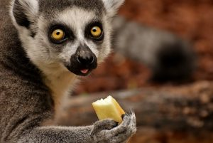
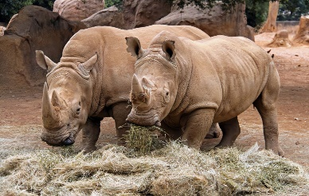
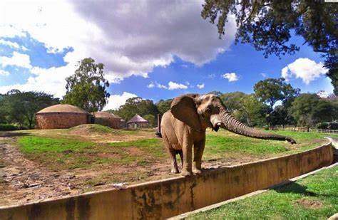
Figure 4: Boggy
Figure 5: Yogi & Ishigaki
Figure 6: Ellie

Directions
The Johannesburg Zoo is located at the corner of Jan Smuts Avenue and Upper Park Drive in Parkview, Johannesburg. The main public entrance is on Upper Park Drive.

Food Services
The zoo's restaurant provides affordable scrumptious meals to suit any occasion and palette, from mouth-watering sandwich, pizza to salads. There are also several kiosks, ice cream and other vendors situated in various sites around the zoo.
Self-Catering is welcome and visitors can make use of a number of open picnic sites available. Please note no cooking using braais onsite are allowed. Please respect the zoo’s open spaces and clean up your litter.

Golf Carts Now Available
Rent a golf cart to explore the Johannesburg Zoo.
Prices start from:
2-seater / R150 per hour
4-seater / R170 per hour
6-seater / R250 per hour
8-seater / R300 per hour

Requirements:
A Driving Licence is required.
No pre-booking is required.
Golf carts are allocated on a first come, first served basis.

Emergency contact info
Contact any zoo staff or the cashiers at the entrances for any assistance during an emergency. The zoo manager and a first aid officer are available to help during office hours.

Emergency numbers:
All life-threatening emergencies:011 375 5911
Ambulance:082 911 or 10177
Police Parkview: 011 486 5000
Zoo Security: 011 646 2000 ext. 230
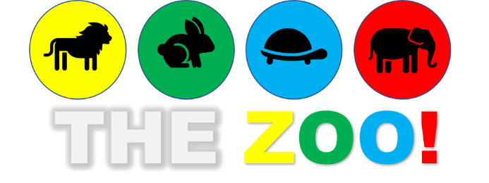
Question/Vraag 1.10

Zoo School
Be Mad Club
Environmental Projects

